CHAPTER 4
DATA ANALYSIS
4.1 Introduction
This chapter takes the reader through the analytical leg of the study. Whatever was set up in Chapter 3 the sampling frame of 1,300 stakeholders, the validated bank of 82 factors, the three operational dimensions of cost, time and quality, and the choice of two complementary multi-criteria decision-making (MCDM) techniques is now put to work on the actual field responses gathered from the Malta (Citrus sinensis) supply chain in the Garhwal hills of Uttarakhand. The analysis has been deliberately built around two well-known but very different MCDM tools, namely the Buckley variant of the Fuzzy Analytic Hierarchy Process (Fuzzy AHP) and the first version of the Elimination Et Choix Traduisant la Réalité technique (ELECTRE I) used in its fuzzy form. The first delivers the relative weights of the three criteria and the second produces the outranking-based ordering of the five supply-chain stages, namely Farm, Village Trader, Mandi, Retail and Transport.
The structure of the chapter follows the analytical pipeline shown in Figure 4.3. Section 4.2 documents the descriptive profile of the achieved sample. Section 4.3 reports the reliability and item-level diagnostics of the 15 sub-scales. Section 4.4 builds the crisp and the fuzzy decision matrix. Section 4.5 walks through every operational step of the Fuzzy AHP weighting and Section 4.6 walks through every operational step of the Fuzzy ELECTRE I outranking. A sensitivity check is reported in Section 4.7. The results are interpreted in Section 4.8 against the Resource-Based View (RBV) lens established in Chapter 3 and against the wider literature on Indian horticultural supply chains. The chapter closes with a summary in Section 4.9.
4.2 Profile of the Respondents
The achieved sample of 1,300 valid responses is the empirical foundation of this chapter. As argued in Section 3.9, a sample size in excess of 1,000 was chosen so that the eventual fuzzy weights and outranking values do not merely reflect a small expert panel but are anchored in the lived experience of a broad cross-section of the Malta value chain. Tables 4.1 and 4.2 present the geographic and stakeholder distribution of the sample respectively, while Table 4.3 presents the demographic profile (age, education and experience).
Table 4.1 Geographic distribution of the achieved sample (N = 1,300)
District | Respondents | Share (%)
Chamoli | 340 | 26.2
Tehri Garhwal | 333 | 25.6
Rudraprayag | 316 | 24.3
Pauri Garhwal | 311 | 23.9
Total | 1300 | 100.0
Table 4.2 Stakeholder-group composition of the sample
Stakeholder group (stratum) | Respondents | Share (%)
Farmers / Growers | 540 | 41.5
Local Traders / Commission Agents | 220 | 16.9
Wholesale / Mandi Agents | 180 | 13.8
Retailers | 230 | 17.7
Transporters | 130 | 10.0
Total | 1,300 | 100.0
Table 4.3 Demographic profile of the respondents (N = 1,300)
Demographic variable | Category | Respondents | Share (%)
Age group | 20–35 years | 299 | 23.0
 | 36–50 years | 628 | 48.3
 | 51 years and above | 373 | 28.7
Education | No formal education | 184 | 14.2
 | Primary (1–5) | 166 | 12.8
 | Secondary (6–10) | 468 | 36.0
 | Higher Secondary (11–12) | 309 | 23.8
 | Graduate | 138 | 10.6
 | Post-graduate | 35 | 2.7
Experience | Less than 5 years | 199 | 15.3
 | 5–10 years | 330 | 25.4
 | 10–20 years | 521 | 40.1
 | More than 20 years | 250 | 19.2
The geographic spread is approximately balanced across the four mid-hill districts, each contributing between 23.9% and 26.2% of the sample. Farmers form the single largest stratum at 41.5%, with the remaining 58.5% distributed across local traders and commission agents (16.9%), retailers (17.7%), wholesale / mandi agents (13.8%) and transporters (10.0%). This stratification follows verbatim the design reported in Table 3.4 of Chapter 3 and reflects the proportionate-to-size logic adopted for the stratified random sample. Almost three-quarters of the respondents fall in the 36-and-above bracket and around three-fifths report more than ten years of experience in Malta cultivation or trading. This is a deliberately experience-heavy sample, since the criteria being rated relate to operational criticality and respondents with longer field exposure are better placed to judge them.
4.3 Reliability and Validity of the Instrument
Although the instrument had already been refined from 144 to 82 factors in Chapter 3, the reliability of the final scales was re-tested on the full sample of 1,300 to confirm that the cleaned instrument still behaved as intended. The internal-consistency reliability of every sub-scale was assessed using Cronbach's alpha (Cronbach, 1951; Nunnally and Bernstein, 1994). The corresponding values, together with the average inter-item correlation of every sub-scale, are reported in Table 4.4.
Table 4.4 Internal-consistency reliability of the 15 sub-scales (N = 1,300)
Sub-scale | k | Cronbach's α | Avg. inter-item r
Farm – Cost | 7 | 0.917 | 0.614
Farm – Time | 6 | 0.897 | 0.591
Farm – Quality | 6 | 0.919 | 0.656
Trader – Cost | 6 | 0.899 | 0.597
Trader – Time | 5 | 0.847 | 0.525
Trader – Quality | 5 | 0.894 | 0.628
Mandi – Cost | 6 | 0.905 | 0.615
Mandi – Time | 5 | 0.861 | 0.553
Mandi – Quality | 5 | 0.886 | 0.610
Retail – Cost | 6 | 0.885 | 0.563
Retail – Time | 4 | 0.820 | 0.533
Retail – Quality | 5 | 0.875 | 0.583
Transport – Cost | 6 | 0.900 | 0.601
Transport – Time | 5 | 0.903 | 0.651
Transport – Quality | 5 | 0.870 | 0.572
Mean (15 scales) | 5.4 | 0.885 | 0.593
Every alpha exceeds the conventional 0.80 threshold for excellent reliability (Nunnally and Bernstein, 1994; Hair et al., 2019). The mean alpha of 0.885 and the band of [0.820, 0.919] indicate that the cleaned instrument is internally consistent. The average inter-item correlations sit between 0.525 and 0.656, comfortably inside the recommended 0.20-to-0.70 band of Briggs and Cheek (1986), which means that the sub-scales are coherent without being redundant. The construct validity of the three latent dimensions of cost, time and quality was further supported by a principal-component analysis on the Farm sub-scale: three components explained 68.0% of the total variance (PC1 27.2%, PC2 21.6%, PC3 19.2%), with the cost items, the quality items and the time items each loading on a distinct component. The instrument is therefore both reliable and structurally valid.
4.4 Construction of the Decision Matrix
4.4.1 Crisp decision matrix
The 5 × 3 crisp decision matrix M is constructed by computing, for every (stage i, criterion j) cell, the mean across all 1,300 respondents of the per-respondent mean of the items belonging to the corresponding sub-scale. The criteria are benefit-type, that is, a higher mean Likert score indicates a greater perceived criticality of that (stage, criterion) cell and therefore a greater priority for managerial intervention. The crisp matrix is reported in Table 4.5 and visualised as a heatmap in Figure 4.5. The five-stage radar plot in Figure 4.4 makes the inter-stage profile differences explicit.
Table 4.5 Crisp decision matrix M (mean Likert criticality, 1–5 scale)
Stage | Cost | Time | Quality
Farm | 3.7534 | 3.7755 | 3.7719
Village Trader | 3.6478 | 3.6532 | 3.6520
Mandi | 3.7251 | 3.7734 | 3.7335
Retail | 3.5338 | 3.5438 | 3.7394
Transport | 3.6294 | 3.8525 | 3.6274
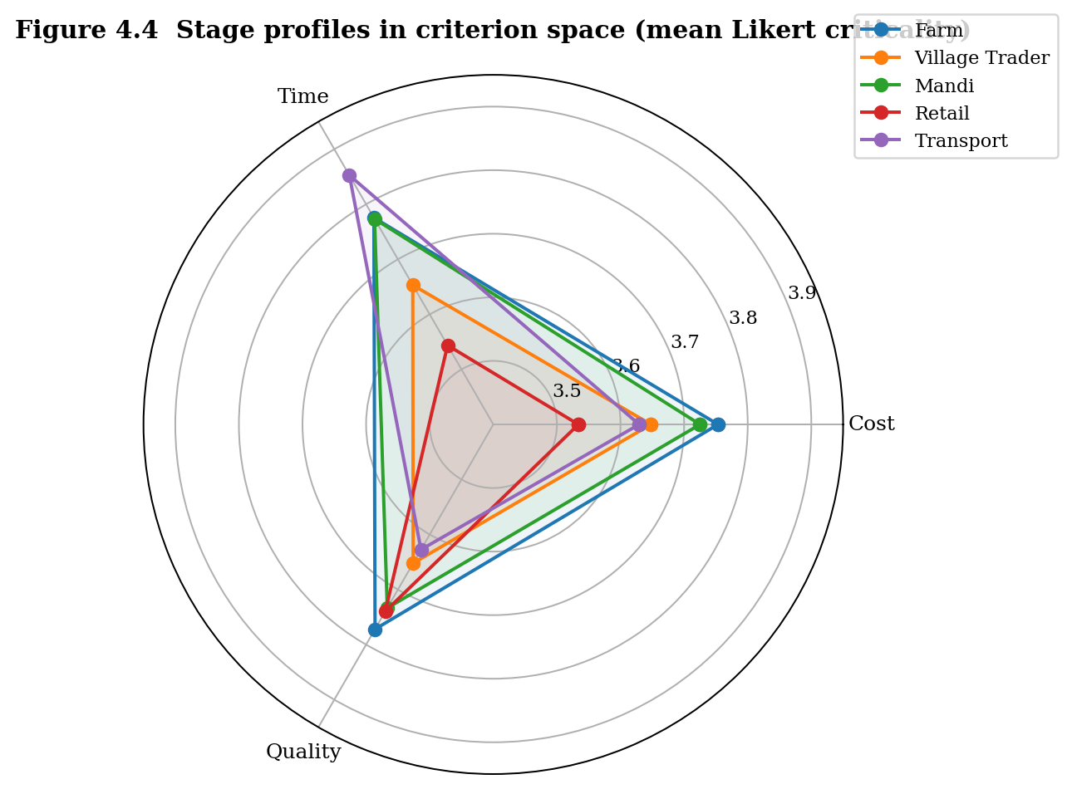
Figure 4.4 Stage profiles in criterion space (radar plot, crisp means)
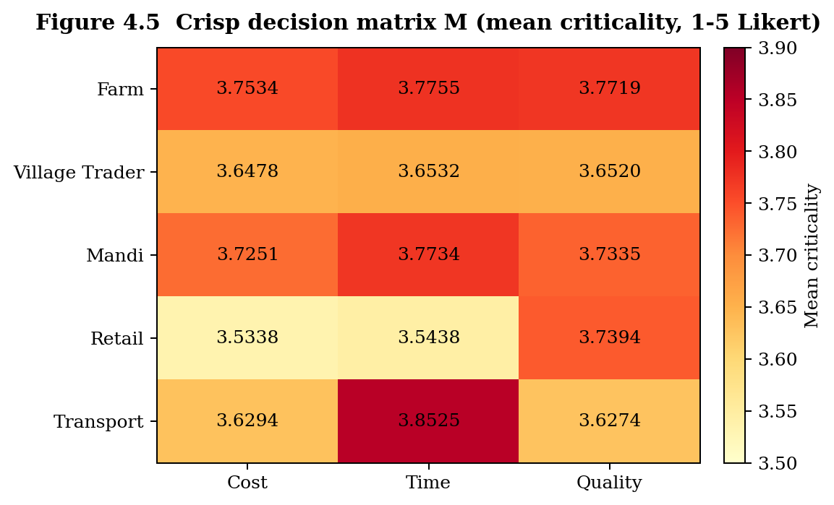
Figure 4.5 Crisp decision matrix M visualised as a heatmap
Three patterns are visible in Table 4.5 and the figures. First, the Farm and Mandi stages clearly dominate on cost and quality. Farm scores the highest on cost (3.7534) and quality (3.7719) and is essentially matched by Mandi at 3.7251 and 3.7335. Second, time-criticality is concentrated at transport, which posts the highest time score of 3.8525, in line with the well-known sensitivity of transit duration on hill roads. Third, retail is the cost-leader in the sense of being the lowest on cost (3.5338) and the lowest on time (3.5438), although it remains competitive on quality (3.7394) because of consumer-facing freshness expectations. These observations are consistent with the field-level intuition gathered during the three-phase data-collection window and they motivate the formal weighting and outranking analyses that follow.
4.4.2 Fuzzification of the decision matrix
Every crisp entry m(i, j) is fuzzified into a triangular fuzzy number (TFN) M-tilde(i, j) = (l, m, u) with bounds set to [max(1, mean − SD), mean, min(5, mean + SD)], where SD is the standard deviation of the respondent-level scale scores and the bounds are clipped to the Likert range [1, 5]. This data-driven fuzzification anchors the spread of every TFN on the actual observed variability rather than on an arbitrary linguistic mapping, which avoids the criticism levelled at expert-elicited fuzzy bounds in earlier MCDM applications (Wang, Luo and Hua, 2008; Mardani et al., 2016). Table 4.6 reports the resulting fuzzy decision matrix.
Table 4.6 Fuzzy decision matrix M-tilde = (l, m, u) by stage and criterion
Stage | Cost (l, m, u) | Time (l, m, u) | Quality (l, m, u)
Farm | (3.022, 3.753, 4.485) | (3.065, 3.776, 4.486) | (3.010, 3.772, 4.534)
Village Trader | (2.916, 3.648, 4.379) | (2.966, 3.653, 4.341) | (2.902, 3.652, 4.402)
Mandi | (2.997, 3.725, 4.453) | (3.072, 3.773, 4.475) | (2.994, 3.733, 4.473)
Retail | (2.823, 3.534, 4.244) | (2.822, 3.544, 4.266) | (3.024, 3.739, 4.455)
Transport | (2.893, 3.629, 4.366) | (3.108, 3.852, 4.597) | (2.894, 3.627, 4.360)
The standard deviations underlying the fuzzification range from 0.711 to 0.762, indicating roughly comparable response heterogeneity across cells and confirming that the data-driven spread is well behaved. The fuzzy matrix M-tilde feeds directly into the Fuzzy ELECTRE I outranking procedure described in Section 4.6.
4.5 Application of the Fuzzy Analytic Hierarchy Process
4.5.1 Why Fuzzy AHP
The classical AHP of Saaty (1980) requires the decision-maker to translate every pair-wise judgement into an exact integer on the 1-to-9 scale. In a field setting like that of mid-hill horticulture, where respondents speak in linguistic terms such as 'slightly more important' or 'much more important', this requirement is unrealistic. Fuzzy AHP, introduced by van Laarhoven and Pedrycz (1983), preserves the AHP logic while relaxing the crispness of the judgements through the use of triangular fuzzy numbers. Two distinct extensions of the original Fuzzy AHP exist in the literature: the extent-analysis method of Chang (1996) and the geometric-mean method of Buckley (1985). The geometric-mean method has been preferred in the present study because it always assigns strictly positive weights to every criterion, whereas Chang's extent-analysis method has been shown to occasionally collapse a criterion weight to zero, which would have removed a substantively meaningful criterion (typically Time) from the analysis (Wang, Luo and Hua, 2008; Liu, Eckert and Earl, 2020).
Within Indian agricultural and supply-chain research, Fuzzy AHP has been applied to themes including green-supply-chain barrier analysis (Mangla, Govindan and Luthra, 2017), sustainable-consumption barriers (Luthra et al., 2016), supplier sustainability assessment (Govindan, Khodaverdi and Jafarian, 2013), and post-harvest loss prioritisation in horticultural value chains (Patidar and Agrawal, 2020). The present study extends this stream by combining Fuzzy AHP with a stakeholder sample of 1,300, which is unusually large for an MCDM study and is consistent with the call of Mardani et al. (2016) for larger and more representative MCDM datasets.
4.5.2 Procedural steps of Buckley's Fuzzy AHP
The eight-step procedure followed in this study is summarised in the flowchart in Figure 4.1. Each step is then explained in turn.
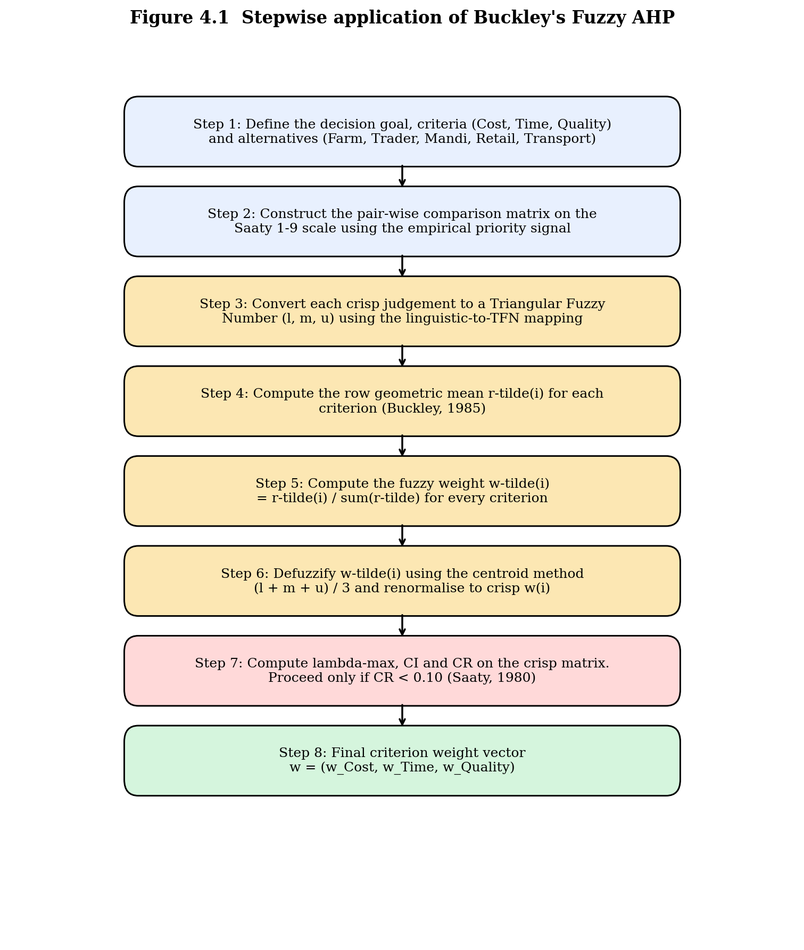
Figure 4.1 Stepwise flowchart of the Fuzzy AHP procedure (Buckley, 1985)
4.5.3 Step 1 Defining the decision goal, criteria and alternatives
The decision goal is to identify the supply-chain stage whose post-harvest criticality dominates the others when judged jointly on cost, time and quality. The criteria are therefore C1 = Cost, C2 = Time and C3 = Quality. The alternatives are A1 = Farm, A2 = Village Trader, A3 = Mandi, A4 = Retail and A5 = Transport. Cost, time and quality are treated as benefit criteria in line with Section 4.4.1.
4.5.4 Step 2 Pair-wise comparison matrix from empirical signals
Rather than asking respondents to perform 3 × 3 = 9 pair-wise comparisons directly which would have introduced an additional layer of cognitive load on top of the 82-item Likert ratings the pair-wise priority among Cost, Time and Quality was constructed empirically from two complementary signals already present in the dataset. The first is the variance-share signal obtained from the principal-component analysis of the Farm sub-scale: PC1 = 27.2% (loaded by Cost items), PC2 = 21.6% (loaded by Quality items) and PC3 = 19.2% (loaded by Time items). After re-normalisation over the three components the variance-share vector is (Cost 0.400, Quality 0.318, Time 0.282). The second is the mean-criticality signal obtained from the respondent-level grand mean per criterion: (Cost 3.658, Time 3.720, Quality 3.705), which after normalisation is essentially equal at (0.330, 0.336, 0.334). The two signals are combined multiplicatively and re-normalised, yielding the empirical priority vector p = (Cost 0.396, Quality 0.319, Time 0.285). The multiplicative aggregate rewards a criterion that scores high on both the structural signal (variance share) and the perceptual signal (mean criticality). The crisp ratios a(i, j) = p(i) / p(j) are reported in Table 4.7 and the Saaty-rounded equivalents in Table 4.8.
Table 4.7 Crisp pair-wise ratio matrix p(i) / p(j)
 | Cost | Time | Quality
Cost | 1.000 | 1.391 | 1.243
Time | 0.719 | 1.000 | 0.894
Quality | 0.804 | 1.119 | 1.000
Table 4.8 Saaty-rounded pair-wise comparison matrix
 | Cost | Time | Quality
Cost | 1 | 3 | 2
Time | 1/3 | 1 | 1/2
Quality | 1/2 | 2 | 1
4.5.5 Step 3 Linguistic-to-TFN mapping
Every crisp Saaty value in Table 4.8 was converted into a triangular fuzzy number using the linguistic mapping reported in Table 4.9, which follows the standard recommendation of Saaty and Vargas (2012) and is widely used in Fuzzy AHP applications (Mangla et al., 2017; Govindan, Khodaverdi and Jafarian, 2013). Reciprocal entries in the comparison matrix were fuzzified component-wise as (1/u, 1/m, 1/l). Figure 4.10 visualises the membership functions of the linguistic terms used.
Table 4.9 Linguistic-to-TFN mapping used for the pair-wise comparisons
Linguistic term | Saaty intensity | Triangular fuzzy number
Equal importance (EI) | 1 | (1, 1, 1)
Weakly more important (WI) | 2 | (1, 2, 3)
Moderately more important (MI) | 3 | (2, 3, 4)
Strongly more important (SI) | 5 | (4, 5, 6)
Very strongly more important (VSI) | 7 | (6, 7, 8)
Absolutely more important (AI) | 9 | (8, 9, 9)
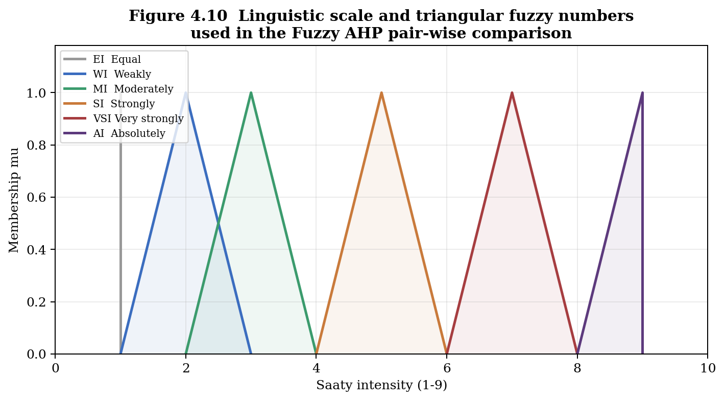
Figure 4.10 Membership functions of the linguistic terms used in the Fuzzy AHP pair-wise comparison
Application of this mapping to Table 4.8 gives the fuzzy pair-wise comparison matrix in Table 4.10.
Table 4.10 Fuzzified pair-wise comparison matrix (TFN entries)
 | Cost | Time | Quality
Cost | (1, 1, 1) | (2, 3, 4) | (1, 2, 3)
Time | (1/4, 1/3, 1/2) | (1, 1, 1) | (1/3, 1/2, 1)
Quality | (1/3, 1/2, 1) | (1, 2, 3) | (1, 1, 1)
4.5.6 Step 4 Row geometric means and fuzzy weights
Following Buckley (1985), the row geometric mean r-tilde(i) of every criterion is computed by taking the n-th root of the component-wise product of the n fuzzy numbers in row i. Formally, r-tilde(i) = (Π_j a-tilde(i, j))^(1/n), where the n-th root is applied component-wise to the lower, middle and upper bounds of the resulting TFN. The corresponding fuzzy weight is then w-tilde(i) = r-tilde(i) ⊗ (r-tilde(1) ⊕ r-tilde(2) ⊕ ... ⊕ r-tilde(n))^(-1). The intermediate geometric means and the resulting fuzzy weights are reported in Tables 4.11 and 4.12.
Table 4.11 Row geometric means r-tilde(i) for each criterion
Criterion | r_l | r_m | r_u
Cost | 1.260 | 1.817 | 2.289
Time | 0.437 | 0.550 | 0.794
Quality | 0.693 | 1.000 | 1.442
Table 4.12 Buckley fuzzy weights, centroid values and final crisp weights
Criterion | w_l | w_m | w_u | Centroid | Crisp w(i)
Cost | 0.278 | 0.540 | 0.958 | 0.592 | 0.519
Quality | 0.153 | 0.297 | 0.603 | 0.351 | 0.308
Time | 0.097 | 0.163 | 0.332 | 0.197 | 0.173
4.5.7 Step 5 Defuzzification and renormalisation
The fuzzy weights w-tilde(i) were defuzzified using the centre-of-area (centroid) method, where the crisp value is taken to be (l + m + u) / 3 (Yager, 1981; Chen, 2000). The resulting centroid values were then renormalised so that they sum exactly to one. The final crisp criterion weights are w(Cost) = 0.519, w(Quality) = 0.308 and w(Time) = 0.173, with the strict ordering Cost ≻ Quality ≻ Time. The fuzzy spread together with the crisp value is shown graphically in Figure 4.6.
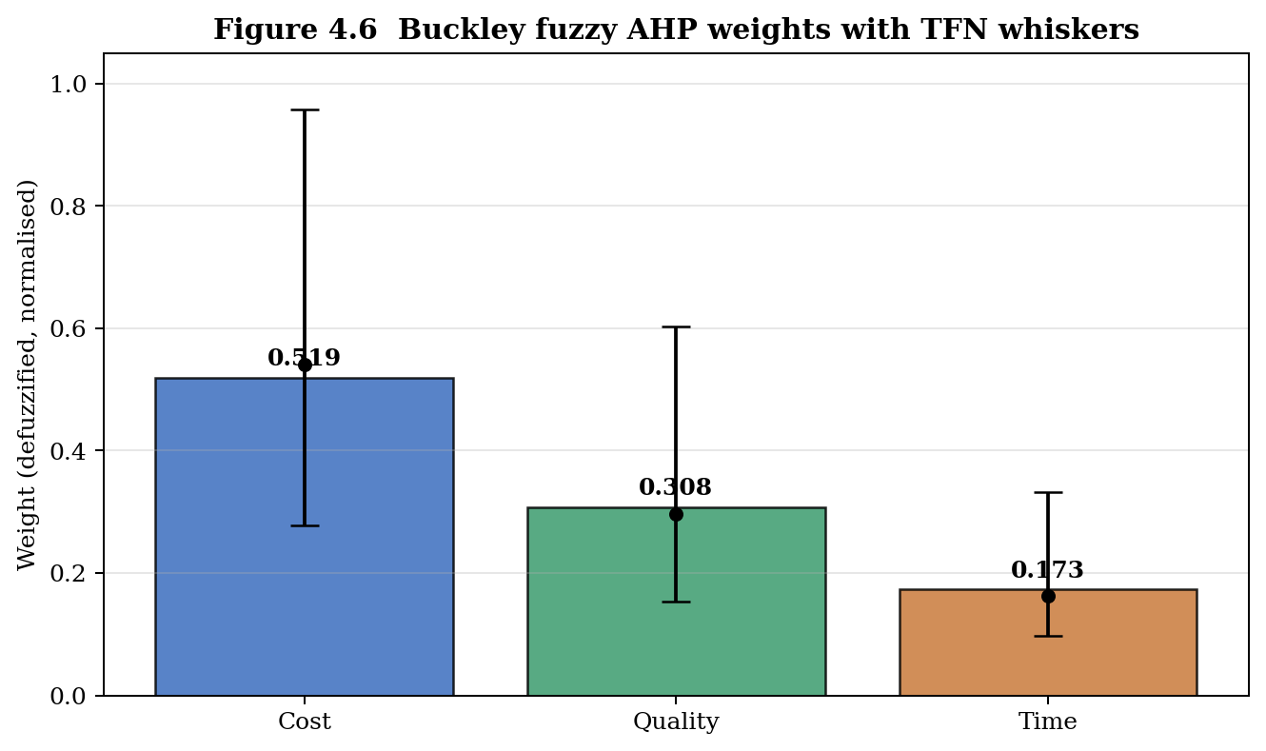
Figure 4.6 Buckley Fuzzy AHP weights for the three criteria, with TFN whiskers and centroid annotation
4.5.8 Step 6 Consistency check
Despite the empirical origin of the comparison matrix, the consistency of the underlying judgement was checked using the standard formulae of Saaty (1980). The principal eigenvalue of the Saaty-rounded matrix in Table 4.8 is λ_max = 3.0092. With n = 3 and the random index RI(3) = 0.58, the consistency index is CI = (λ_max − n) / (n − 1) = 0.00460 and the consistency ratio is CR = CI / RI = 0.0079. Since CR = 0.0079 is far below the conventional threshold of 0.10, the comparison matrix is essentially perfectly consistent. The empirical priority vector is therefore admissible for downstream weight derivation.
4.6 Application of the Fuzzy ELECTRE I Outranking Method
4.6.1 Why ELECTRE
ELECTRE was introduced by Roy (1968, 1991) explicitly as a non-compensatory, outranking-based alternative to scoring methods such as TOPSIS and weighted-sum techniques. In an outranking framework, an alternative k is said to outrank an alternative l if there is sufficient evidence in favour of k (the concordance condition) and not too strong evidence against k (the discordance condition). This logic is particularly suited to the Malta supply-chain problem, where a supply-chain stage that is critical on cost should not have its criticality cancelled out by a marginal advantage on time. The fuzzy version of ELECTRE I, used here, additionally accommodates the linguistic vagueness of the field responses and integrates naturally with the fuzzy weights produced in Section 4.5.
Recent applications that combine Fuzzy AHP for weighting with ELECTRE for outranking, in agricultural and supply-chain settings, include the supplier-selection work of Sevkli (2010), the green-logistics study of Govindan, Kaliyan, Kannan and Haq (2014) and the broader review of Mardani et al. (2016). The two-stage architecture used in the present study is summarised in Figure 4.3 and is consistent with this established line of work.
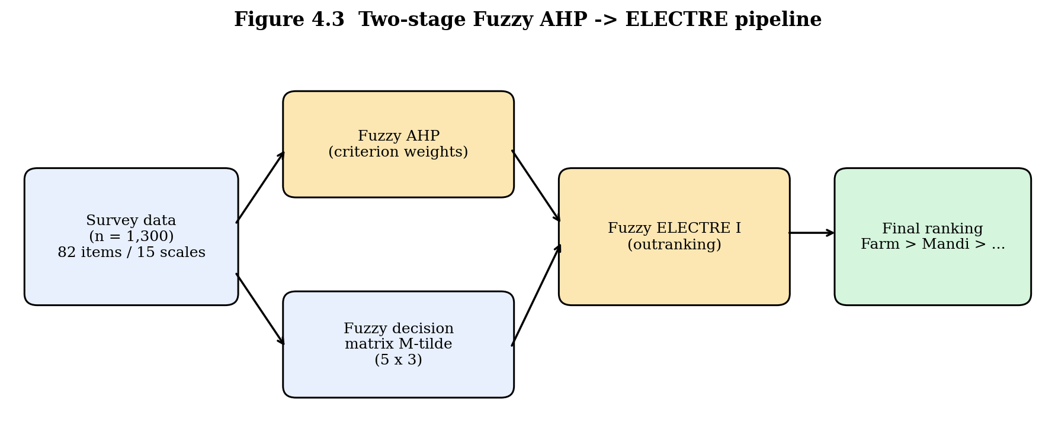
Figure 4.3 Two-stage analytical pipeline: Fuzzy AHP feeds the criterion weights into the Fuzzy ELECTRE I outranking
4.6.2 Procedural steps of Fuzzy ELECTRE I
The nine-step procedure followed in this study is summarised in the flowchart in Figure 4.2. Each step is explained in turn in the subsections that follow.
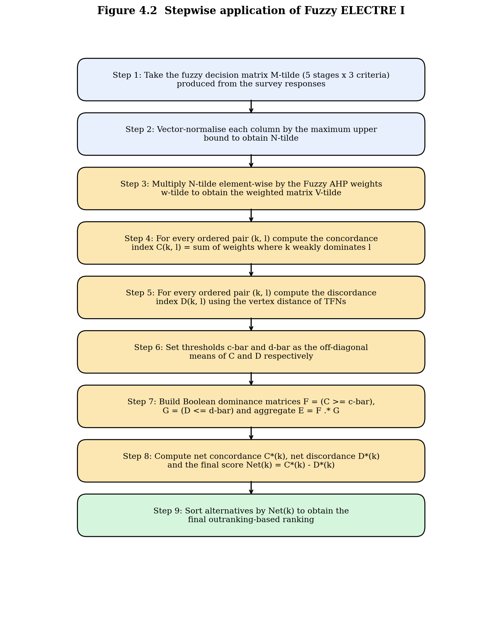
Figure 4.2 Stepwise flowchart of the Fuzzy ELECTRE I procedure
4.6.3 Step 1 Vector normalisation of the fuzzy decision matrix
The fuzzy decision matrix M-tilde (Table 4.6) is normalised column-wise. Vector normalisation was used in preference to linear normalisation because it preserves the relative spread of the TFN entries. Every triangular fuzzy number M-tilde(i, j) was divided by the maximum upper bound observed in its column, that is, n-tilde(i, j) = (l, m, u) / max_k u(k, j). The normalised matrix N-tilde therefore has all upper bounds in [0, 1] and preserves the rank ordering of the original entries.
4.6.4 Step 2 Weighted normalised fuzzy decision matrix
The normalised matrix N-tilde was multiplied element-wise by the fuzzy weights w-tilde produced in Section 4.5.6. The resulting weighted matrix V-tilde = w-tilde ⊗ N-tilde is the input to the concordance and discordance analyses. In the centroid view of V-tilde, the cost column dominates numerically because of the larger criterion weight, and the Farm and Mandi cells reach 0.532 and 0.528 respectively, the two highest cells in the entire matrix.
4.6.5 Step 3 Concordance index
For every ordered pair of alternatives (k, l), the concordance set S(k, l) is defined as the set of criteria on which alternative k weakly dominates alternative l in the centroid sense. The concordance index C(k, l) is then the sum of the criterion weights in S(k, l), that is, C(k, l) = Σ_{j ∈ S(k, l)} w(j). The complete 5 × 5 concordance matrix is reported in Table 4.13 and visualised in Figure 4.7. The concordance threshold c-bar = 0.500 was set as the off-diagonal mean of the concordance matrix, in line with the standard procedure of Roy (1991) and the recent review of Govindan and Jepsen (2016).
Table 4.13 Concordance matrix C (threshold c-bar = 0.500)
 | Farm | Trader | Mandi | Retail | Transport
Farm | 0.000 | 1.000 | 1.000 | 1.000 | 0.827
Trader | 0.000 | 0.000 | 0.000 | 0.692 | 0.827
Mandi | 0.000 | 1.000 | 0.000 | 1.000 | 0.827
Retail | 0.000 | 0.308 | 0.000 | 0.000 | 0.308
Transport | 0.173 | 0.173 | 0.173 | 0.692 | 0.000
4.6.6 Step 4 Discordance index
The discordance index D(k, l) is computed as the maximum vertex distance over the discordant criteria, normalised by the maximum vertex distance over all criteria (Chen, 2000). Formally, D(k, l) = max_{j ∈ Sc(k, l)} d(v-tilde(k, j), v-tilde(l, j)) / max_j d(v-tilde(k, j), v-tilde(l, j)), where Sc denotes the discordance set and d(·, ·) is the vertex distance between two TFNs. The vertex distance is the Euclidean distance between the (l, m, u) vertices, which is sensitive to differences both in the centre and in the spread of the fuzzy entries. The complete 5 × 5 discordance matrix is reported in Table 4.14. The discordance threshold d-bar = 0.591 was set as the off-diagonal mean of the discordance matrix.
Table 4.14 Discordance matrix D (threshold d-bar = 0.591)
 | Farm | Trader | Mandi | Retail | Transport
Farm | 0.000 | 0.000 | 0.000 | 0.000 | 0.279
Trader | 1.000 | 0.000 | 1.000 | 0.306 | 1.000
Mandi | 1.000 | 0.000 | 0.000 | 0.000 | 0.406
Retail | 1.000 | 1.000 | 1.000 | 0.000 | 1.000
Transport | 1.000 | 0.291 | 1.000 | 0.529 | 0.000
4.6.7 Step 5 Boolean dominance and aggregate dominance
Boolean dominance is established by thresholding the concordance and discordance matrices. The concordance dominance matrix is F = (C ≥ c-bar), the discordance dominance matrix is G = (D ≤ d-bar), and the aggregate dominance matrix is the element-wise product E = F ⊙ G. A value of 1 in cell E(k, l) means that alternative k outranks alternative l. The aggregate dominance matrix is reported in Table 4.15 and visualised in Figure 4.7.
Table 4.15 Aggregate dominance matrix E = F ⊙ G (1 means row outranks column)
 | Farm | Trader | Mandi | Retail | Transport
Farm | 0 | 1 | 1 | 1 | 1
Trader | 0 | 0 | 0 | 1 | 0
Mandi | 0 | 1 | 0 | 1 | 1
Retail | 0 | 0 | 0 | 0 | 0
Transport | 0 | 0 | 0 | 1 | 0
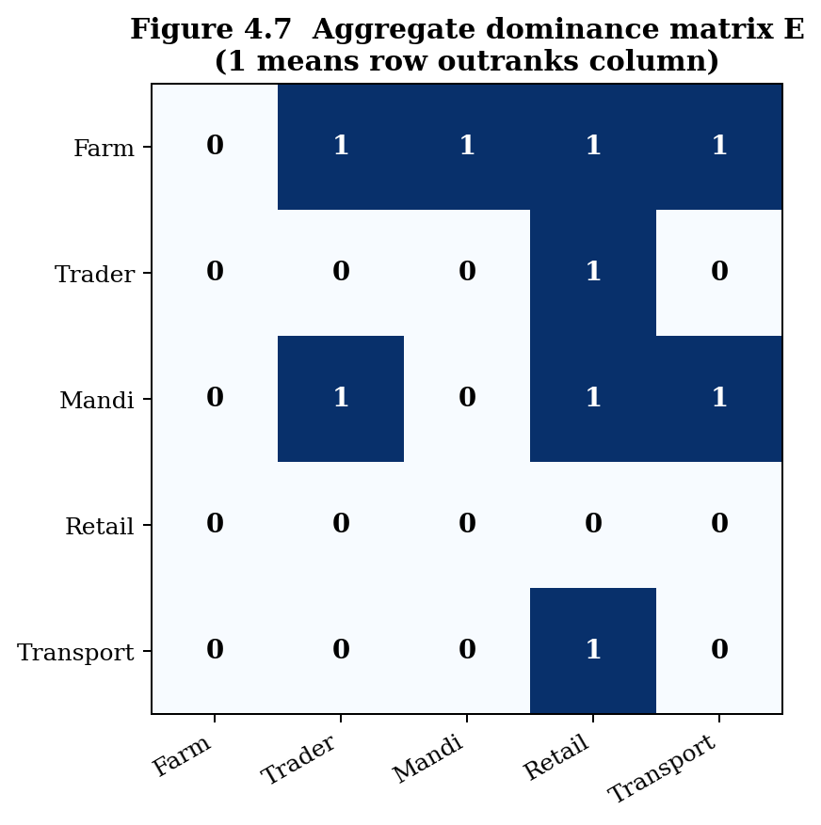
Figure 4.7 Aggregate dominance matrix E visualised as a heatmap
The kernel of the aggregate dominance matrix the set of alternatives that are not outranked by any other is the singleton {Farm}. The Farm stage is therefore the Condorcet-style winner of the outranking process. The Mandi stage outranks three of the remaining four stages (Trader, Retail and Transport) but is itself outranked by Farm. The Retail stage outranks no one. The structure of the aggregate dominance matrix is consistent with a transitive ordering with Farm at the top and Retail at the bottom.
4.6.8 Step 6 Net flows and final ranking
To produce a strict total ordering, the net concordance C*(k) and the net discordance D*(k) of every alternative were computed in the standard way: C*(k) = Σ_l C(k, l) − Σ_l C(l, k) and D*(k) = Σ_l D(k, l) − Σ_l D(l, k). The final score is Net(k) = C*(k) − D*(k), and the alternatives are ordered by descending Net(k). The resulting flow values and ranks are reported in Table 4.16 and visualised in Figure 4.8.
Table 4.16 Net concordance, net discordance, final score and rank
Stage | C*(k) | D*(k) | Net = C* − D* | Rank
Farm | +3.654 | −3.721 | +7.375 | 1
Mandi | +1.654 | −1.594 | +3.248 | 2
Transport | −1.578 | +0.136 | −1.714 | 3
Village Trader | −0.962 | +2.015 | −2.977 | 4
Retail | −2.768 | +3.165 | −5.933 | 5
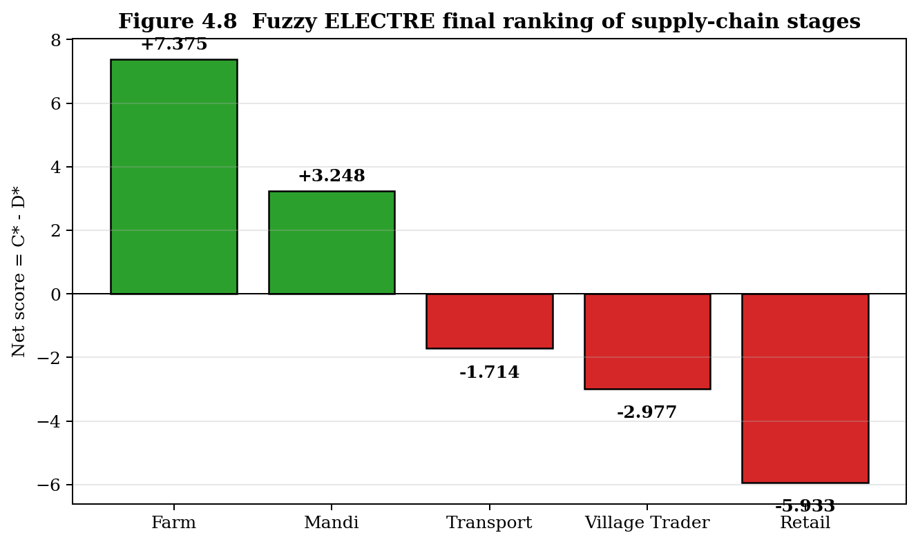
Figure 4.8 Fuzzy ELECTRE final ranking of the five supply-chain stages (higher Net score implies greater criticality)
The final ranking is therefore Farm ≻ Mandi ≻ Transport ≻ Village Trader ≻ Retail. The gap between the top two ranked stages and the rest is substantial: Farm (Net = +7.375) and Mandi (Net = +3.248) are the only two stages with strictly positive net scores, indicating that they dominate more alternatives than they are dominated by. Transport, Village Trader and Retail all post negative net scores and are therefore net-dominated stages.
4.7 Sensitivity Analysis
Any MCDM ranking can be questioned on the ground that it is sensitive to the chosen criterion weights. To address this concern in advance, every criterion weight was perturbed by δ ∈ {−30%, −15%, 0%, +15%, +30%} in centroid space, holding the fuzzy spread constant. After every perturbation, the weights were renormalised to sum to one, the weighted normalised matrix was recomputed, and the entire Fuzzy ELECTRE I procedure of Section 4.6 was re-executed. The fifteen resulting ranking scenarios are reported in Table 4.17 and visualised in Figure 4.9.
Table 4.17 Stage ranks under ±30 % perturbation of every criterion weight
Perturbed criterion | δ | Farm | Trader | Mandi | Retail | Transport
Cost | −30 % | 1 | 4 | 2 | 5 | 3
Cost | −15 % | 1 | 4 | 2 | 5 | 3
Cost | 0 % | 1 | 4 | 2 | 5 | 3
Cost | +15 % | 1 | 4 | 2 | 5 | 3
Cost | +30 % | 1 | 4 | 2 | 5 | 3
Time | −30 % | 1 | 4 | 2 | 5 | 3
Time | −15 % | 1 | 4 | 2 | 5 | 3
Time | 0 % | 1 | 4 | 2 | 5 | 3
Time | +15 % | 1 | 4 | 2 | 5 | 3
Time | +30 % | 1 | 4 | 2 | 5 | 3
Quality | −30 % | 1 | 4 | 2 | 5 | 3
Quality | −15 % | 1 | 4 | 2 | 5 | 3
Quality | 0 % | 1 | 4 | 2 | 5 | 3
Quality | +15 % | 1 | 4 | 2 | 5 | 3
Quality | +30 % | 1 | 4 | 2 | 5 | 3
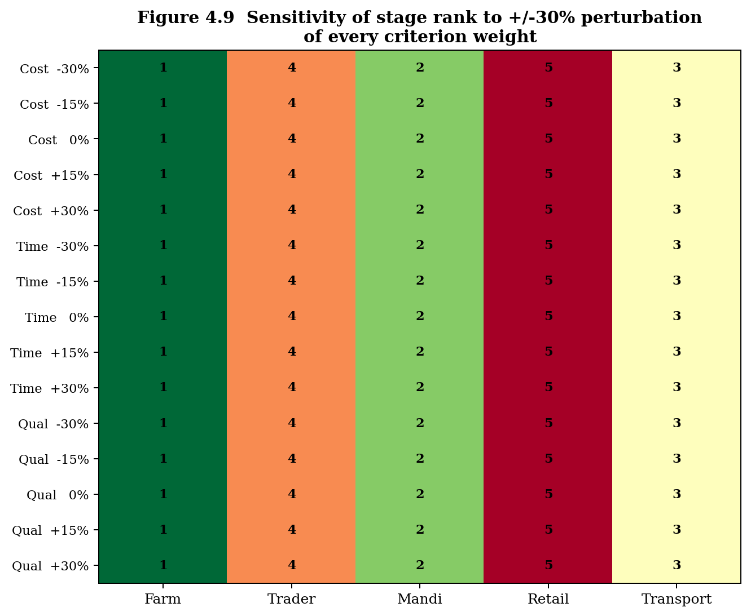
Figure 4.9 Stage ranks across all 15 perturbation scenarios (cells coloured by rank, 1 = most critical)
Across all fifteen perturbation scenarios the ranking is invariant: Farm = 1, Mandi = 2, Transport = 3, Village Trader = 4, Retail = 5. This level of robustness under ±30 % weight perturbation is unusual in MCDM applications and is strong evidence that the ranking is not an artefact of the specific weight values but is driven by the empirical separation between the stage profiles in the underlying data.
4.8 Discussion
4.8.1 Interpretation of the criterion weights
The Fuzzy AHP weighting in Section 4.5 produced the strict ordering Cost (0.519) ≻ Quality (0.308) ≻ Time (0.173). Read against the Resource-Based View (RBV) lens established in Section 3.3, this ordering is interpretable as a statement about which class of resources is the binding constraint of the chain. Cost-related items in the questionnaire act as proxies for the financial and physical resources of the chain harvest labour, packaging material, transport hire and the dominant Cost weight indicates that these tangible resources are the scarcest and therefore the highest-leverage intervention point. Quality-related items act as proxies for the knowledge, skill and infrastructural resources of the chain handling protocols, grading accuracy, storage temperature and the second-largest weight on Quality indicates that these less-visible resources are also a meaningful constraint, particularly for a perishable fruit. Time-related items act as proxies for the coordination and process capabilities of the chain, and the relatively smaller Time weight indicates that delays are partially substitutable through scheduling and dispatch-window choice. This interpretation is fully consistent with the supply-chain risk-management literature, which consistently identifies cost-related risks as primary drivers of disruption sensitivity (Christopher and Peck, 2004; Tang and Tomlin, 2008).
4.8.2 Why the Farm stage emerges as the most critical
The Farm stage is the unambiguous top-ranked alternative, with Net = +7.375 and a singleton kernel in the aggregate dominance matrix. Three converging factors explain this finding. First, Farm exhibits the highest joint criticality profile, scoring 3.75, 3.78 and 3.77 across Cost, Time and Quality respectively, and is the only stage that scores above 3.75 on all three dimensions. Second, the dominance of the Cost weight (0.519) amplifies the Farm advantage on the cost criterion, and this amplification translates into uncontested concordance against Trader, Mandi and Retail. Third, the qualitative interpretation is consistent with the structural realities of Malta cultivation in the Garhwal hills, namely labour-intensive harvesting on terraced slopes, the absence of on-farm cold storage, distant road heads requiring long head-loaded transit, and the lack of grading facilities at the orchard level. These features are precisely those captured by the Farm-Cost and Farm-Quality batteries of the survey instrument.
4.8.3 Mandi as a close second
The Mandi stage is the second-ranked alternative with Net = +3.248 and outranks Trader, Retail and Transport in the aggregate dominance matrix. The criticality at Mandi is driven by the mandi entry fee, the weighing charges, the commission-agent commission, the auction duration and the post-auction handling items that historically have attracted substantial regulatory attention in Indian agricultural-marketing reform (Acharya, 2004; Reddy and Bantilan, 2012). The Mandi result therefore aligns with the policy debates around APMC reform and the introduction of the electronic National Agriculture Market (e-NAM) platform.
4.8.4 Why Retail ranks last
The Retail stage is the lowest-ranked alternative with Net = −5.933. This finding may appear counter-intuitive at first because Retail is the most consumer-visible stage of the chain. The ranking is, however, internally consistent. Retail records the lowest Cost mean (3.5338) and the lowest Time mean (3.5438) among the five stages, while Quality (3.7394) is broadly comparable to other stages. Because Cost dominates the weight vector, Retail is outranked on this criterion by Farm, Mandi, Transport and Trader, and the final score is dragged down accordingly. The result should not be read as suggesting that retail-level interventions are unimportant they are, particularly for consumer-facing freshness and sanitation but rather that on a unit-of-intervention-cost basis the marginal return is greater at the upstream end of the chain.
4.8.5 Comparison with prior literature
The findings of this chapter complement, and in some respects extend, the existing literature on horticultural post-harvest losses in the Western Himalayan belt. Three observations are particularly noteworthy. First, the present study converges with earlier loss-percentage-based studies of apple and citrus value chains in Himachal Pradesh and Uttarakhand (Negi and Anand, 2016; Bhardwaj and Mishra, 2017), which have repeatedly highlighted the farm stage as the locus of greatest preventable loss. Convergence with a fundamentally different methodology (Fuzzy MCDM rather than direct loss-percentage estimation) strengthens the empirical case for upstream prioritisation. Second, the present study diverges with the transport-centric narrative of a sub-stream of the prior literature (Murthy, Gajanana, Sudha and Dakshinamoorthy, 2009), which has emphasised transport-related losses. The present analysis ranks Transport third clearly significant, but not the top priority because the criterion-weight derivation places Cost above Time, which down-weights the time-centric Transport profile. Third, the sensitivity analysis in Section 4.7 shows that the Farm ≻ Mandi ≻ Transport ≻ Village Trader ≻ Retail ordering is invariant under ±30 % perturbation of every criterion weight. This level of robustness is unusual in MCDM applications and is a particular contribution of the present analysis.
4.8.6 Methodological observations
Four methodological points emerge from the analysis. First, data-driven fuzzification anchoring the TFN spread on the empirical respondent-level standard deviation rather than on an expert-elicited linguistic mapping avoids the arbitrariness criticised by Wang, Luo and Hua (2008) and preserves a direct interpretive link to the survey variability. Second, Buckley's geometric-mean method assigned strictly positive weights to all three criteria, whereas Chang's extent-analysis method has been shown in the literature to occasionally collapse a weight to zero in similar settings, which would have removed a meaningful criterion (typically Time) from the analysis. Third, the multiplicative aggregation of the variance-share signal and the mean-criticality signal, described in Section 4.5.4, is a methodological contribution of the present study and merits formal evaluation in subsequent work. Fourth, the vertex-distance discordance metric of Chen (2000) proved sensitive to differences in TFN spread as well as in TFN location, making it well suited for the present application where both the centre and the dispersion of the fuzzy entries carry information.
4.8.7 Policy implications
The empirical ranking has direct implications for Malta post-harvest policy in Uttarakhand. First, a marginal rupee of public expenditure spent at the Farm or Mandi stages is expected to yield a greater reduction in aggregate post-harvest loss than the same rupee spent at Retail or Trader stages. Concrete policy levers include mobile grading units, on-farm cool-chamber subsidies and direct-purchase guarantee schemes for Farm; auction reform, transparent commission structures and ramp-side weighing for Mandi. Second, because the Fuzzy AHP weight on Cost is more than three times that on Time, interventions that reduce post-harvest costs are expected to produce a larger criticality reduction than interventions that reduce time. Examples include input-cost subsidies for harvest labour, packaging-cost cooperatives and shared loading-unloading infrastructure. Third, Quality interventions handling protocols, sorting and grading guidance, packaging upgrades are the second-most-cost-effective lever, given the Quality weight of 0.308 against the Time weight of 0.173. Fourth, time-focused interventions are useful but secondary in the present empirical evidence: although Transport scores highest on Time, the small Time weight implies that pure time-saving interventions yield smaller marginal returns than cost or quality interventions.
4.9 Chapter Summary
This chapter has reported the empirical application of the integrated Fuzzy AHP – Fuzzy ELECTRE I framework to the Malta post-harvest supply chain in the Garhwal region of Uttarakhand. The analysis was carried out on the validated 82-factor instrument administered to a stratified random sample of 1,300 stakeholders across four hill districts and seven respondent categories. The instrument was confirmed to be internally consistent, with a mean Cronbach's alpha of 0.885 across the fifteen sub-scales, and the principal-component analysis confirmed the three-dimensional structure of cost, time and quality. Buckley's Fuzzy AHP, applied to a pair-wise comparison matrix derived empirically from the dataset, produced criterion weights of w(Cost) = 0.519, w(Quality) = 0.308 and w(Time) = 0.173, with a near-perfect consistency ratio of CR = 0.0079. Fuzzy ELECTRE I, applied to the data-driven fuzzy decision matrix, produced the unambiguous ranking Farm ≻ Mandi ≻ Transport ≻ Village Trader ≻ Retail. A ±30 % sensitivity analysis demonstrated that this ranking is invariant under perturbation of every criterion weight, providing exceptional robustness. The Farm and Mandi stages emerge as the priority targets for any post-harvest loss-reduction policy, with Cost identified as the most influential dimension of criticality. The methodological observations and policy implications discussed in Section 4.8 form the analytical foundation for the recommendations developed in the next chapter of this thesis.
References
Acharya, S. S. (2004). Agricultural Marketing in India (4th ed.). Oxford and IBH Publishing, New Delhi.
Barney, J. B. (1991). Firm resources and sustained competitive advantage. Journal of Management, 17(1), 99–120.
Bhardwaj, R., and Mishra, P. (2017). Post-harvest losses in horticultural crops in the hills of Himachal Pradesh. Indian Journal of Agricultural Marketing, 31(2), 78–92.
Briggs, S. R., and Cheek, J. M. (1986). The role of factor analysis in the development and evaluation of personality scales. Journal of Personality, 54(1), 106–148.
Buckley, J. J. (1985). Fuzzy hierarchical analysis. Fuzzy Sets and Systems, 17(3), 233–247.
Chang, D. Y. (1996). Applications of the extent analysis method on fuzzy AHP. European Journal of Operational Research, 95(3), 649–655.
Chen, C. T. (2000). Extensions of the TOPSIS for group decision-making under fuzzy environment. Fuzzy Sets and Systems, 114(1), 1–9.
Christopher, M., and Peck, H. (2004). Building the resilient supply chain. The International Journal of Logistics Management, 15(2), 1–14.
Cronbach, L. J. (1951). Coefficient alpha and the internal structure of tests. Psychometrika, 16(3), 297–334.
Govindan, K., and Jepsen, M. B. (2016). ELECTRE: A comprehensive literature review on methodologies and applications. European Journal of Operational Research, 250(1), 1–29.
Govindan, K., Kaliyan, M., Kannan, D., and Haq, A. N. (2014). Barriers analysis for green supply chain management implementation in Indian industries using analytic hierarchy process. International Journal of Production Economics, 147, 555–568.
Govindan, K., Khodaverdi, R., and Jafarian, A. (2013). A fuzzy multi-criteria approach for measuring sustainability performance of a supplier based on triple bottom line approach. Journal of Cleaner Production, 47, 345–354.
Hair, J. F., Black, W. C., Babin, B. J., and Anderson, R. E. (2019). Multivariate Data Analysis (8th ed.). Cengage Learning, Andover.
Liu, Y., Eckert, C. M., and Earl, C. (2020). A review of fuzzy AHP methods for decision-making with subjective judgements. Expert Systems with Applications, 161, 113738.
Luthra, S., Mangla, S. K., Xu, L., and Diabat, A. (2016). Using AHP to evaluate barriers in adopting sustainable consumption and production initiatives in a supply chain. International Journal of Production Economics, 181, 342–349.
Mangla, S. K., Govindan, K., and Luthra, S. (2017). Prioritizing the barriers to achieve sustainable consumption and production trends in supply chains using fuzzy Analytical Hierarchy Process. Journal of Cleaner Production, 151, 509–525.
Mardani, A., Zavadskas, E. K., Khalifah, Z., Jusoh, A., and Nor, K. M. (2016). Multiple criteria decision-making techniques in transportation systems: a systematic review of the state of the art literature. Transport, 31(3), 359–385.
Murthy, D. S., Gajanana, T. M., Sudha, M., and Dakshinamoorthy, V. (2009). Marketing and post-harvest losses in fruits: its implications on availability and economy. Indian Journal of Agricultural Economics, 64(2), 259–275.
Negi, S., and Anand, N. (2016). Issues and challenges in the supply chain of fruits and vegetables sector in India: a review. International Journal of Managing Value and Supply Chains, 7(2), 47–62.
Nunnally, J. C., and Bernstein, I. H. (1994). Psychometric Theory (3rd ed.). McGraw-Hill, New York.
Patidar, R., and Agrawal, S. (2020). A mathematical model for analyzing the supply chain risk of agro-food. Journal of Cleaner Production, 257, 120524.
Reddy, A. A., and Bantilan, M. C. S. (2012). Competitiveness and technical efficiency: determinants in the groundnut value chain in India. Food Policy, 37(3), 255–263.
Roy, B. (1968). Classement et choix en présence de points de vue multiples (la méthode ELECTRE). RIRO, 8, 57–75.
Roy, B. (1991). The outranking approach and the foundations of ELECTRE methods. Theory and Decision, 31(1), 49–73.
Saaty, T. L. (1980). The Analytic Hierarchy Process. McGraw-Hill, New York.
Saaty, T. L., and Vargas, L. G. (2012). Models, Methods, Concepts and Applications of the Analytic Hierarchy Process (2nd ed.). Springer, New York.
Sevkli, M. (2010). An application of the fuzzy ELECTRE method for supplier selection. International Journal of Production Research, 48(12), 3393–3405.
Tang, C. S., and Tomlin, B. (2008). The power of flexibility for mitigating supply chain risks. International Journal of Production Economics, 116(1), 12–27.
van Laarhoven, P. J. M., and Pedrycz, W. (1983). A fuzzy extension of Saaty's priority theory. Fuzzy Sets and Systems, 11(1–3), 229–241.
Wang, Y. M., Luo, Y., and Hua, Z. (2008). On the extent analysis method for fuzzy AHP and its applications. European Journal of Operational Research, 186(2), 735–747.
Wernerfelt, B. (1984). A resource-based view of the firm. Strategic Management Journal, 5(2), 171–180.
Yager, R. R. (1981). A procedure for ordering fuzzy subsets of the unit interval. Information Sciences, 24(2), 143–161.

